## Week 3 Quiz

**TOTAL POINTS 10**

**1.Question 1**

**Because smart speakers can carry out multiple functions (such as tell a joke, play music, etc.) it is an example of Artificial General Intelligence (AGI).**



True



False

1 point

**2.Question 2**

**What are the key steps to a smart speaker function?**



Trigger word detection -> intent recognition -> speech recognition -> command execution.



Trigger word detection -> speech recognition -> intent recognition -> command execution.



Speech recognition → Trigger word detection -> intent recognition -> command execution.



Trigger detection -> intent recognition -> speech recognition -> command execution.

1 point

**3.Question 3**

**Consider this system for building a self-driving car:**

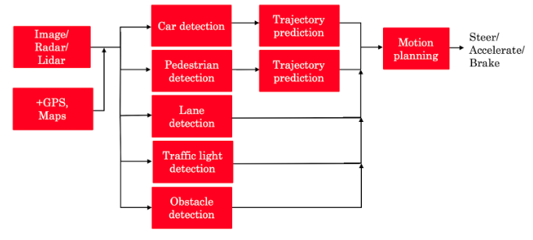

**The component for pedestrian detection is usually built using:**



A motion planning algorithm



Supervised learning



GANs



Reinforcement learning

1 point

**4.Question 4**

**Suppose you are building a trigger word detection system, and want to hire someone to build a system to map from Inputs A (audio clip) to Outputs B (whether the trigger word was said), using existing AI technology. Out of the list below, which of the following hires would be most suitable for writing this software?**



AI Product Manager



Machine learning researcher



Machine learning engineer



Data engineer

1 point

**5.Question 5**

**What is the first step in the AI Transformation Playbook for helping your company become good at AI?**



Execute pilot projects to gain momentum



Build an in-house AI team



Develop an AI strategy



Provide broad AI training

1 point

**6.Question 6**

**Of the following options, which is the most important trait of your first pilot project?**



Succeed and show traction within 6-10 months



Drive extremely high value for the business



Be executed by an in-house team



None of the above

1 point

**7.Question 7**

**Say you are building a smart speaker, and want to accumulate data for your product through having many users. Which of these represents the “Virtuous circle of AI” for this product?**



1. ans

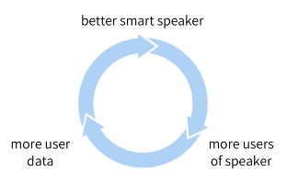



(B)

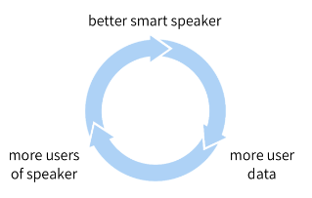



(C)

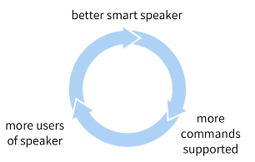



(D)

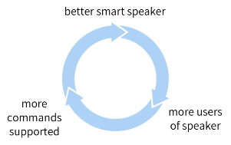

1 point

**8.Question 8**

**Why is developing an AI strategy NOT the first step in the AI Transformation Playbook?**



Without having some practical AI experience and knowing what it feels like to build an AI project, a company usually does not know enough to formulate a sound strategy.



When transforming a company into an AI company, one does not need a strategy, therefore it can’t be the first step.



There is no reason. Developing an AI strategy IS the first step in the AI Transformation Playbook.



The strategy should be to use the Virtuous Circle of AI, which comes after building a product.

1 point

**9.Question 9**

**According to the AI Transformation Playbook, broad AI training needs to be provided not only to engineers, but also to executives/senior business leaders and to leaders of divisions working on AI projects.**



True



False

1 point

**10.Question 10**

**Which of the following are AI pitfalls to avoid? (Select all that apply)**



Expecting AI to solve everything



Expecting traditional planning processes to apply without changes



Pairing engineering talent with business talent to identify feasible and valuable projects.



Expecting AI based projects to work the first time

1 point

## Week 4 Quiz

**TOTAL POINTS 10**

**1.Question 1**

**What are the current limitations of AI technology? (Select all that apply)**



AI technology can discriminate



AI technology is susceptible to adversarial attacks



Explainability is hard



AI technology can be biased



There are no limitations to AI technology

1 point

**2.Question 2**

**What is the Goldilocks Rule of AI?**



An AI winter is coming



One should allocate many resources to defend the world from giant killer robots



One shouldn’t be too optimistic or too pessimistic about AI technology



AI’s technology will continue to grow and can only benefit society

1 point

**3.Question 3**

**Say you are building an AI system to help make diagnoses from X-ray scans. Which of the following statements about explainability of AI do you agree with?**



Explainability is usually achieved through building a chatbot to talk to the user to explain its outputs.



Lack of explainability can hamper users’ willingness to trust and adopt an AI system.



AI systems are intrinsically “black box” and cannot give any explanation for their outputs.



Most AI systems are highly explainable, meaning that it’s easy for a doctor to figure out why an AI system gave a particular diagnosis.

1 point

**4.Question 4**

**Using current AI technology, if a machine learning system learns from text that reflects unhealthy biases/stereotypes, then the resulting AI software may also exhibit similarly unhealthy biases/stereotypes.**



True



False

1 point

**5.Question 5**

**Using current AI technology, if a machine learning system learns only from text that is completely neutral and does not reflect any gender biases, then we would expect it to exhibit no, or at most minimal, gender bias.**



True



False

1 point

**6.Question 6**

**Which of these are good practices for addressing bias in AI? (Select all that apply)**



Using more inclusive/less biased data



Systematic auditing processes to check for bias



Technical solution such as “zeroing out” bias



Using an adversarial attack on the AI system to change its outputs to be less biased

1 point

**7.Question 7**

**Which of these are examples of adversarial attacks on an AI system? (Select all that apply)**



Using AI to synthesize a fake video of a politician saying something they never actually said.



Subtly modifying an audio clip to make a speech recognition system think someone said “Yes, authorized” when they actually said “No, reject.”



Subtly changing an image to make an AI system mistakenly recognize a dog as a cat.



Adding a sticker to a stop sign to make an AI system fail to detect it.

1 point

**8.Question 8**

**If a developing economy has a strong and thriving coffee bean manufacturing industry (or some other vertical industry), then it has an advantage in applying AI to coffee bean manufacturing (or other vertical industry).**



True



False

1 point

**9.Question 9**

**What are the jobs that AI is most likely to displace over the next several years?**



Jobs that comprise primarily of routine, repetitive work



Most jobs involving office work (white collar jobs)



All jobs will be displaced



Jobs that comprise primarily of non-routine, non-repetitive work

1 point

**10.Question 10**

**Congratulations! You deserve a pat on the back for finishing this course.**



True



False

1 point